|  |  |
| --- | --- |
|  |  |
|  |
|  |

**High Impact Skills Development Program for Gilgit Baltistan**

**Computer Vision Module Project**

**Project Title:** Expression Classification from Facial Images

**Learning Objectives:**

* Understand the fundamentals of using a deep ConvNet
* Learn how to use Tensorflow/Keras
* Learn how to use Google Colab
* Learn how to train (fine-tune) a convolutional neural network architecture

**Overview:**

Learning discriminative features for expressions from facial images captured in the wild is a non-trivial task due to intra-class variations and inter-class similarities. Furthermore, background clutter, illumination changes, large pose variations, and partial or full occlusions make it more challenging. The goal of this project is to design and develop a computer vision system that can classify facial expressions. Such a system can have several real-world applications. For example, expressions can be useful for Human-Computer Interaction based recommendation systems to determine whether to push product information or not. It can also be used to determine the psychological state of a person during online interviews. Overall, this project will provide students with a practical opportunity to implement the concepts learnt during the module. It will also allow them to understand practical problems where computer vision can provide solutions. Students will engage in the identification of tools and techniques that can be employed to solve those problems.

**Dataset:**

The dataset selected for this task is the **Expression in-the-Wild (ExpW)[1]** dataset. The dataset can be downloaded from the following link:

<https://drive.google.com/drive/folders/1SDcI273EPKzzZCPSfYQs4alqjL01Kybq>

The **Expression in-the-Wild (ExpW)** dataset is for facial expression recognition and contains 91,793 faces manually labeled with expressions (Figure 1). Each of the face images is annotated as one of the seven basic expression categories: “angry (0)”, “disgust (1)”, “fear (2)”, “happy (3)”, “sad (4)”, “surprise (5)”, or “neutral (6)”.

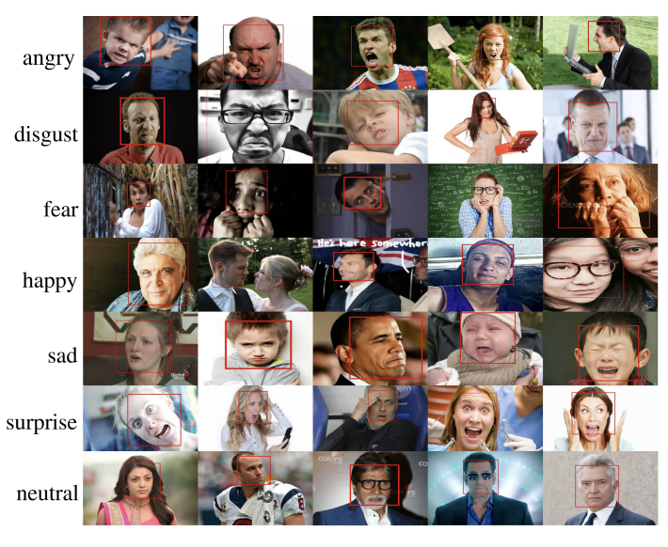

Figure 1: Sample Images from ExpW Dataset

The project can be divided into several stages:

**Preprocessing:** Apply any necessary processing techniques to remove noise or increase dataset via augmentation, etc. if required.

**Training:** Split the data into Training/Validation/Test. Use a deep learning framework such as Keras or TensorFlow or any other to train a Convolutional Neural Network on the annotated dataset. You can either create a customized model or employ a pre-trained network (either fine-tuned or as feature extractor).

**Testing:** The model should be tested on a separate test set of images that was not used for training, to ensure that it can generalize to new data.

**Evaluation:** Evaluate the performance of the model by measuring its accuracy, precision, recall, and other relevant metrics. Make sure to plot a confusion matrix to determine which expression class is predicted correctly and which is challenging for your model.

**Requirements:**

1. Create account on GitHub
2. Share your profile link in the project report (to be submitted at the end of your project)
3. Upload your code to GitHub
4. Prepare a short 3-4 page report about your project that should contain:
   1. Project Title
   2. Your name, email address, github profile link
   3. A 100 word summary of your project
   4. Project Details

* Overview of the problem and potential application areas
* A brief literature review (refer at least 2 articles from 2022-23) - highlight the

work, data, accuracy reported, pros and cons.

* Model you used (architecture, diagram, main components, parameters)
* Dataset you used in the project -stats, data division (training,

validation, test)

* Hyperparameter tuning
* Results and Evaluations
* Analysis of results-What are good results? What are bad results and why? A confusion matrix can help provide deeper insight.
* How can you further improve the results?

5. Prepare a 5 slide presentation of your project and the work you have done.

6. Upload your project report and slides to the respective folders in LMS.

**Timeline for Module Project:**

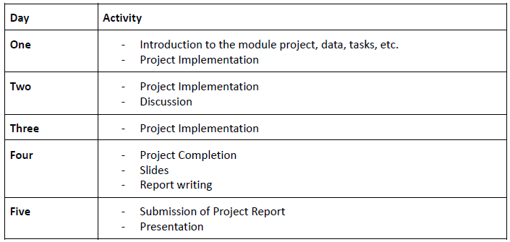

1. Zhang, Z., Luo, P., Loy, C. C., & Tang, X. (2018). From facial expression recognition to interpersonal relation prediction. *International Journal of Computer Vision*, *126*, 550-569.